

**AIML Final REPORT**

**Group-2 CV 1**

**CAPSTONE PROJECT**

Table of Contents

ABOUT THIS DOCUMENT 3

PROBLEM STATEMENT 4

PROJECT 5

Milestone 1 5

Step 1: Import the data. 5

Step 2: Map training and testing images to its classes. 11

Step 3: Map training and testing images to its annotations. 14

Step 4: Preprocessing and Visualisation of different classes 15

Step 5: Display images with bounding box. 17

Step 6: Design, train and test basic CNN models for classification. 25

Milestone 2 36

Step 1: Fine tune the trained basic CNN models for classification. 36

Step 2: Apply Transfer Learning model for classification 41

Step 3: Design, train and test RCNN & its hybrids based object detection models to impose the bounding box or mask over the area of interest. 45

Step 4: Pickle the model for future prediction 61

CONCLUSION 62

# ABOUT THIS DOCUMENT

Title: Final Report

Date: 24/12/2023

Project Name: PNEUMONIA DETECTION CHALLENGE

Authors/Contributors: **Sephalika Nayak, Aabshar Pasha, Darshan Sethiya & Manvendra Wagadre**

Purpose: To design a DL based algorithm for detecting pneumonia.

Acknowledgments: Special Thanks to Mr Jayant for mentoring us during this Capstone project.

# PROBLEM STATEMENT

* **DOMAIN**: Health Care
* **CONTEXT**:

Computer vision can be used in health care for identifying diseases. In Pneumonia detection we need to detect Inflammation of the lungs. In this challenge, you’re required to build an algorithm to detect a visual signal for pneumonia in medical images. Specifically, your algorithm needs to automatically locate lung opacities on chest radiographs.

* **DATA DESCRIPTION**:

In the dataset, some of the features are labeled “Not Normal No Lung Opacity”. This extra third class indicates that while pneumonia was determined not to be present, there was nonetheless some type of abnormality on the image and oftentimes this finding may mimic the appearance of true pneumonia. Dicom original images: - Medical images are stored in a special format called DICOM files (*.dcm). They contain a combination of header metadata as well as underlying raw image arrays for pixel data.

Dataset has been attached along with this project. Please use the same for this capstone project

Original link to the dataset: https://www.kaggle.com/c/rsna-pneumonia-detection-challenge/data [for your reference only]. You can refer to the det ails of the dataset in the above link

Acknowledgements: <https://www.kaggle.com/c/rsna-pneumonia-detection-challenge/overview/acknowledgements>.

* **PROJECT OBJECTIVE**: Design a DL based algorithm for detecting pneumonia.
* **PROJECT TASK**: [ Score: 100 points]

**Milestone 1**: [ Score: 40 points]

**Input**: Context and Dataset

**Process**:

* Import the data. [ 3 points]
* Map training and testing images to its classes. [ 4 points]
* Map training and testing images to its annotations. [ 4 points]
* Preprocessing and Visualisation of different classes [4 Points]
* Display images with bounding box. [ 5 points]
* Design, train and test basic CNN models for classification. [ 10 points]
* Interim report [ 10 points]

# PROJECT

## Milestone 1

We had downloaded data to our local machine and unzipped to a location in local folder.

Local path:

C:\Users\manve\Downloads\rsna-pneumonia-detection-challenge

### Step 1: Import the data.

We had used Python with the pandas library to read CSV files and define file paths.

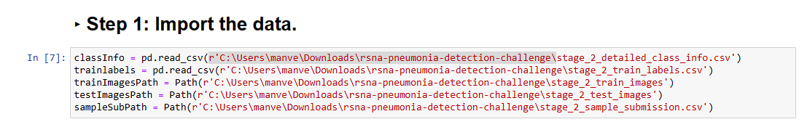

Exploratory data analysis:

There are 26684 unique patient info available. Total numbers of records are 30227, but unique patient IDs are 26684. We observe some duplicated records for patient Id. 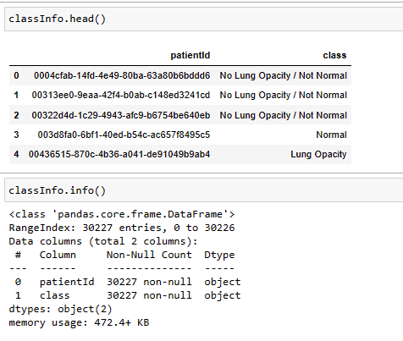

There are two features 1. Patient ID 2. Class.

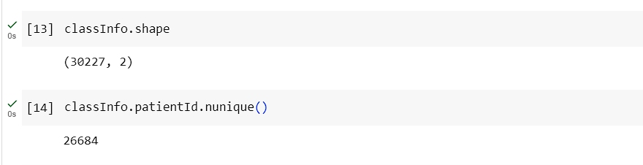

we observed 3543 duplicated records.

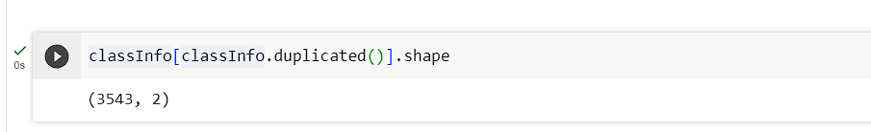

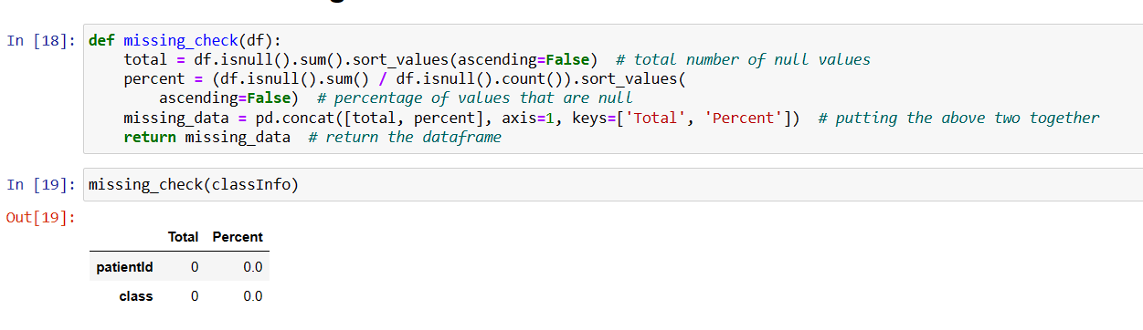

There are no missing values.

**Reading the Trainlabels dataset:**

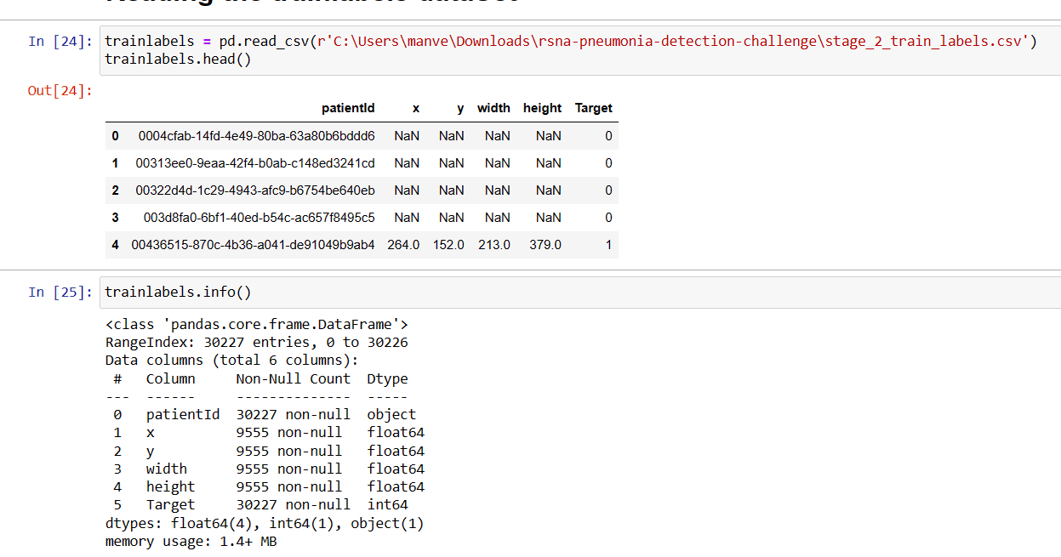

We observed there are X, Y values are missing for few records. This can be due to the fact that for a normal patient these values could be not applicable.

We noticed 75% of the data represents target value 1. We can see the same in Count plot. It’s an imbalanced data set.

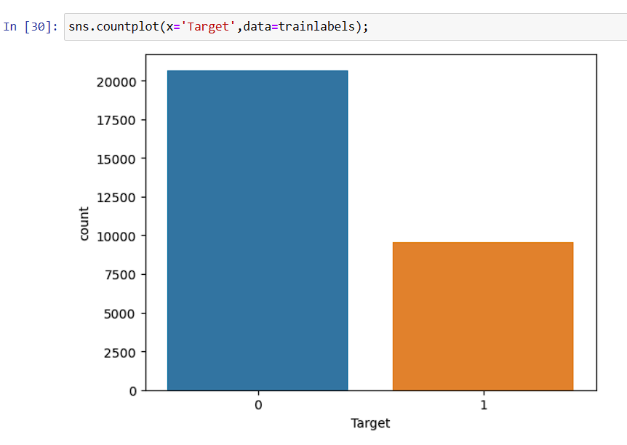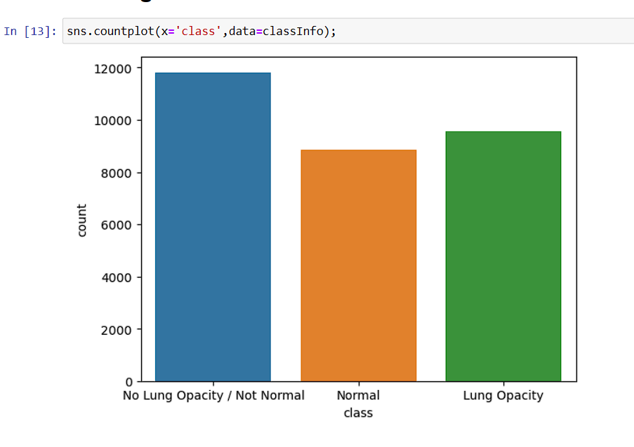

We can see three different classes in the above count plot which are

1. Normal
2. No Lung Opacity / Not Normal
3. Lung Opacity

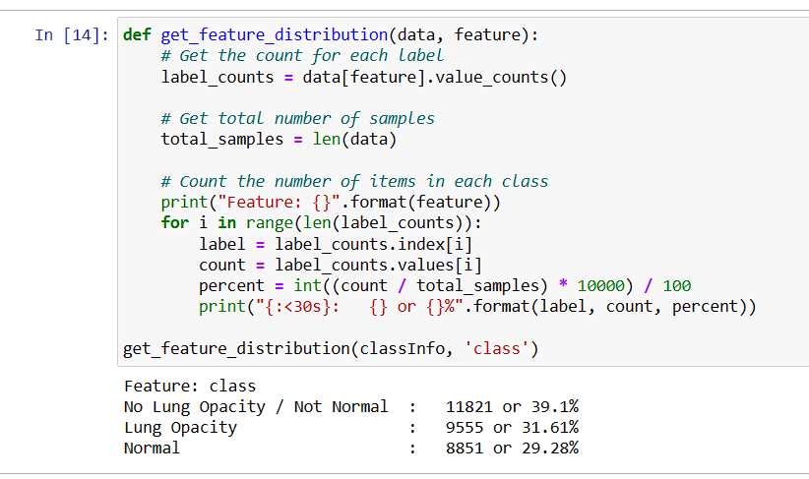

Its proved that only for normal patients dimensions are not available.

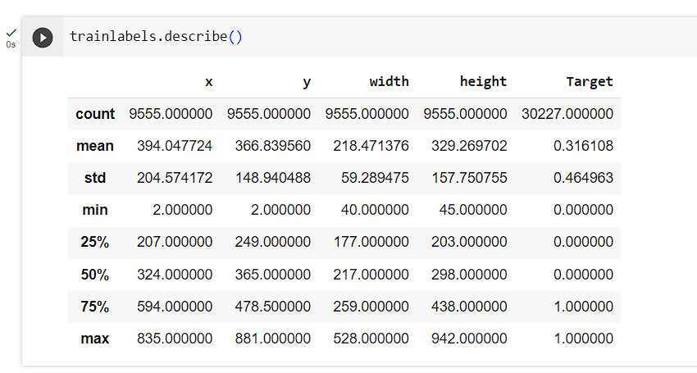

Trainlabels contains 30227 records same as meta data.

We had concatenated classInfo and Trainlabels. Before concatenating them, we removed duplicate records from classInfo.

We observed X & Y values are missing for few records. This can be due to the fact that for a normal patient these values could be not applicable.

There are 31.6% of patients with pneumonia and the remaining 68.4% are no pneumonia.

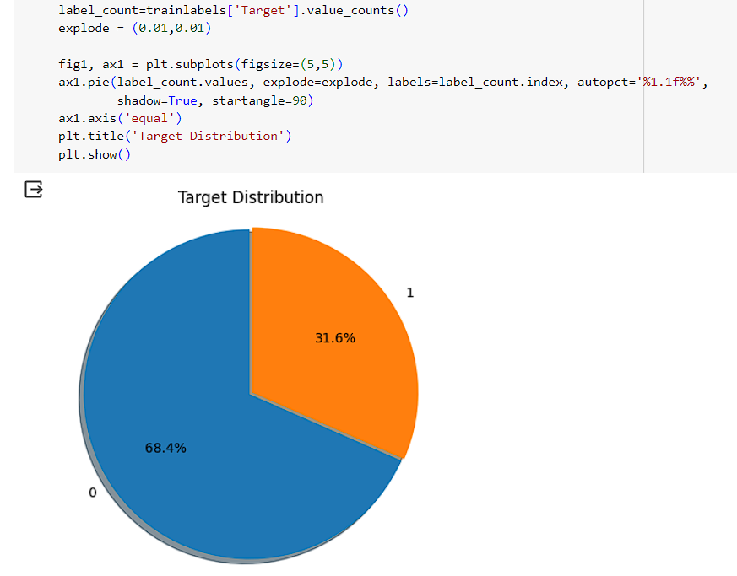

### Step 2: Map training and testing images to its classes.

We had done inner merge between two DataFrames, trainlabels and classInfo, based on the common column 'patientId'.

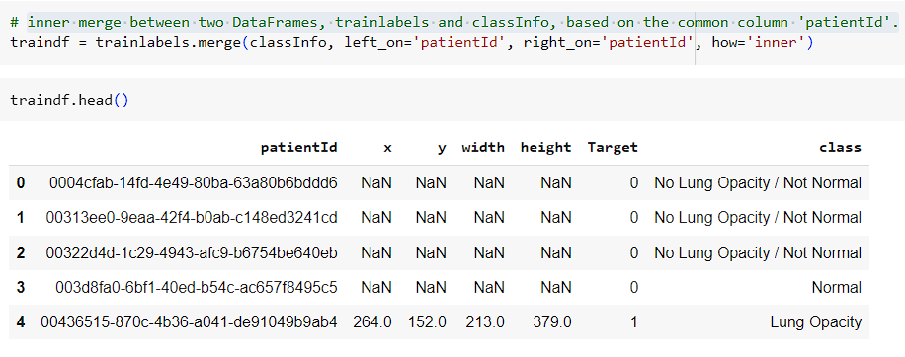

We observed class with Normal and No Lung Opacity / Not Normal has been classified into single target value that is 'O'. So, we can say that the prediction which we have to do is like patient has Lung Opacity or not. Because Normal and not normal patients are combines in same Target.

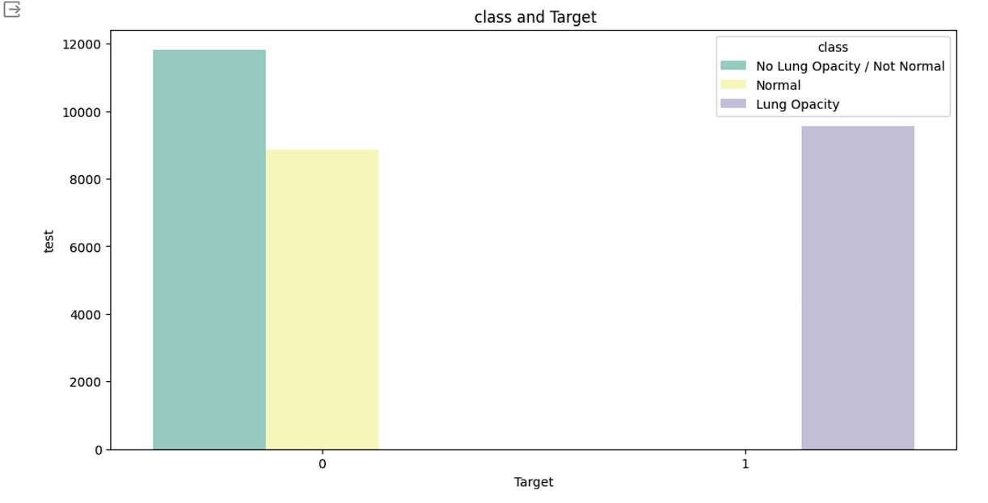

Prediction: Binary classification i.e., Patient has Lung Opacity or not?

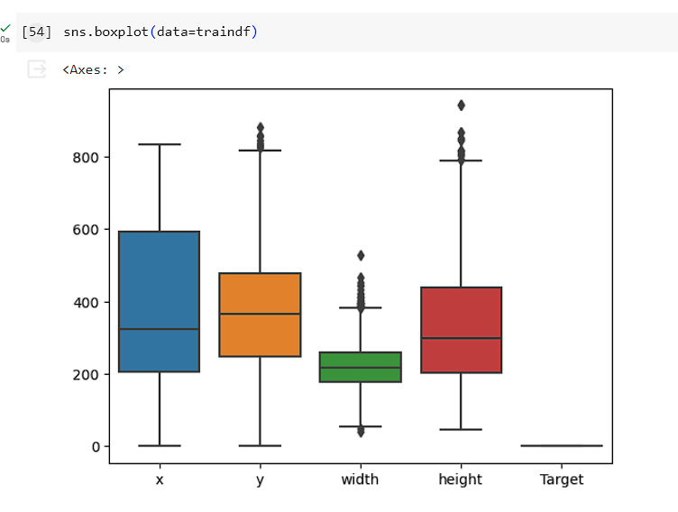

We can see the distribution plot with respect to X, Y, height and width.

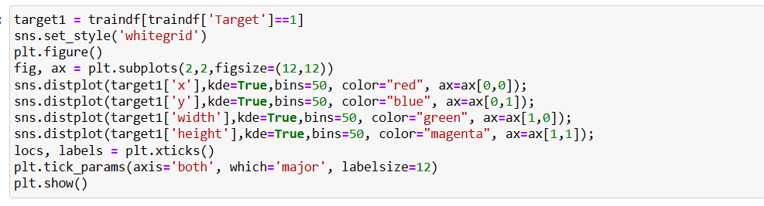

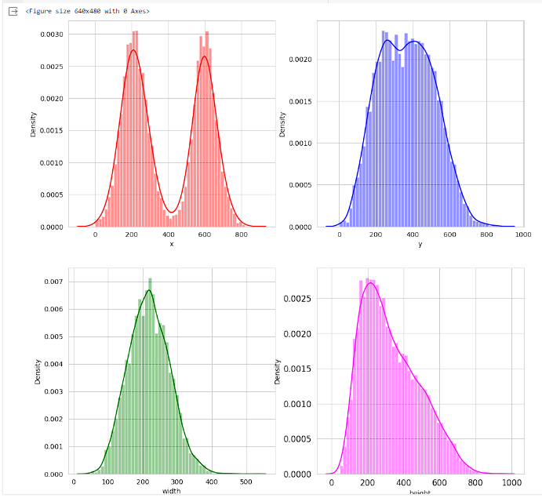

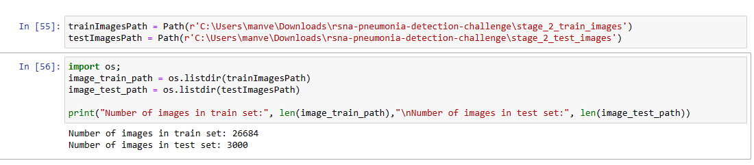

Number of images in train set: 26684

Number of images in test set: 3000

We observed Train images length matched with unique patient id's in traindf.

### Step 3: Map training and testing images to its annotations.

We had read DICOM file using the pydicom library based on a specific patient ID from traindf DataFrame.

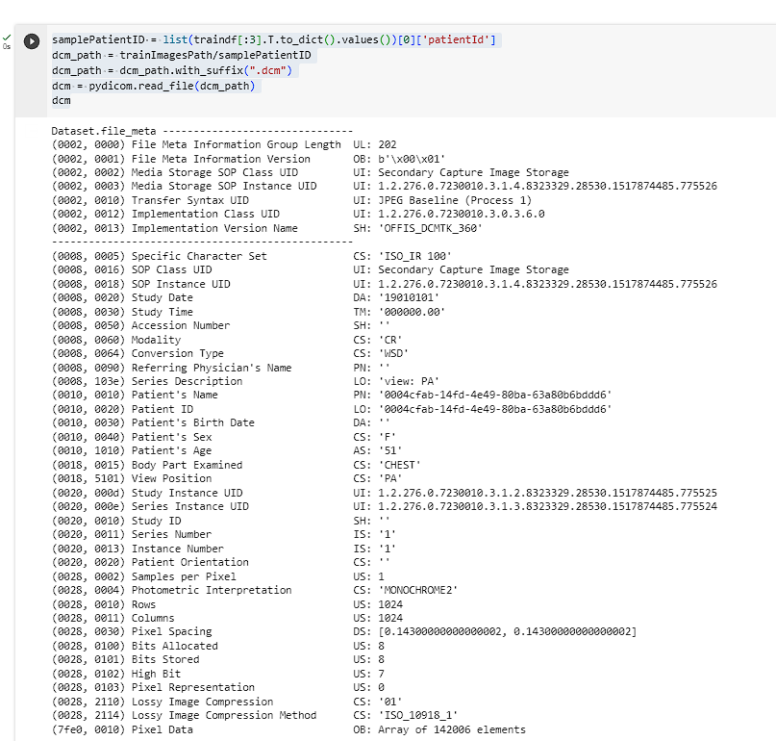

### Step 4: Preprocessing and Visualisation of different classes

We can observe that we do have available some useful information in the DICOM metadata with predictive value, for example:

* Patient sex
* Patient age
* Modality
* Body part examined
* View position
* Rows & Columns
* Pixel Spacing

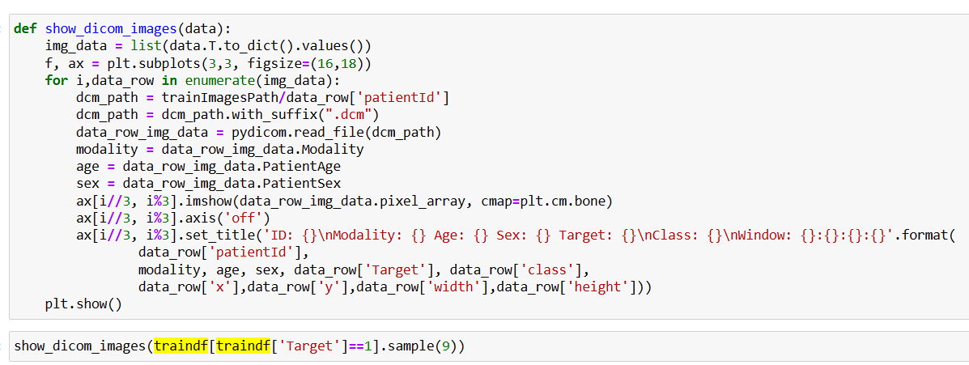

To visualize the images with overlay boxes superimposed, our initial step involves parsing the entire dataset where the target is equal to 1.

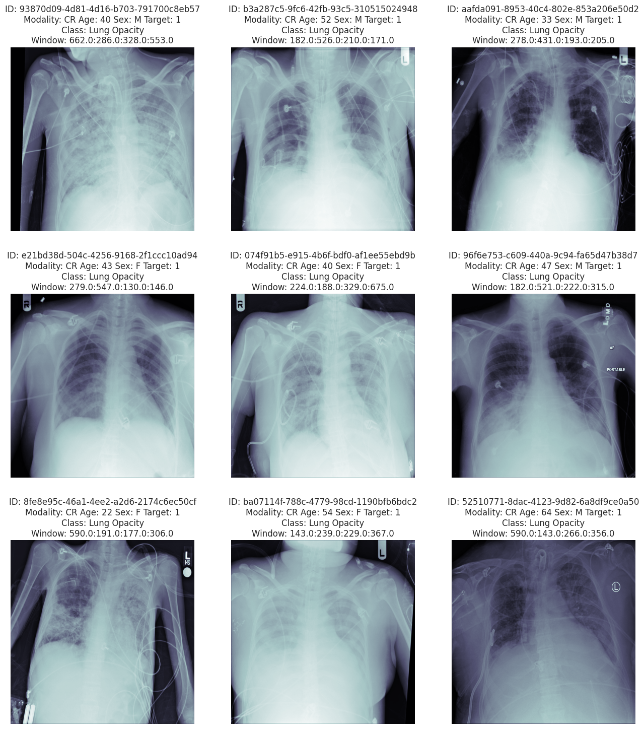

### Step 5: Display images with bounding box.

We can see the bounding boxes for the patient with Pneumonia in the below images output.

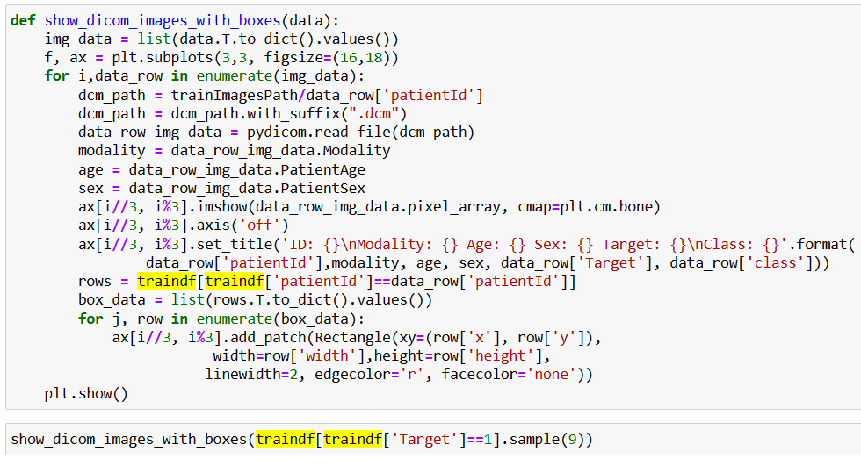

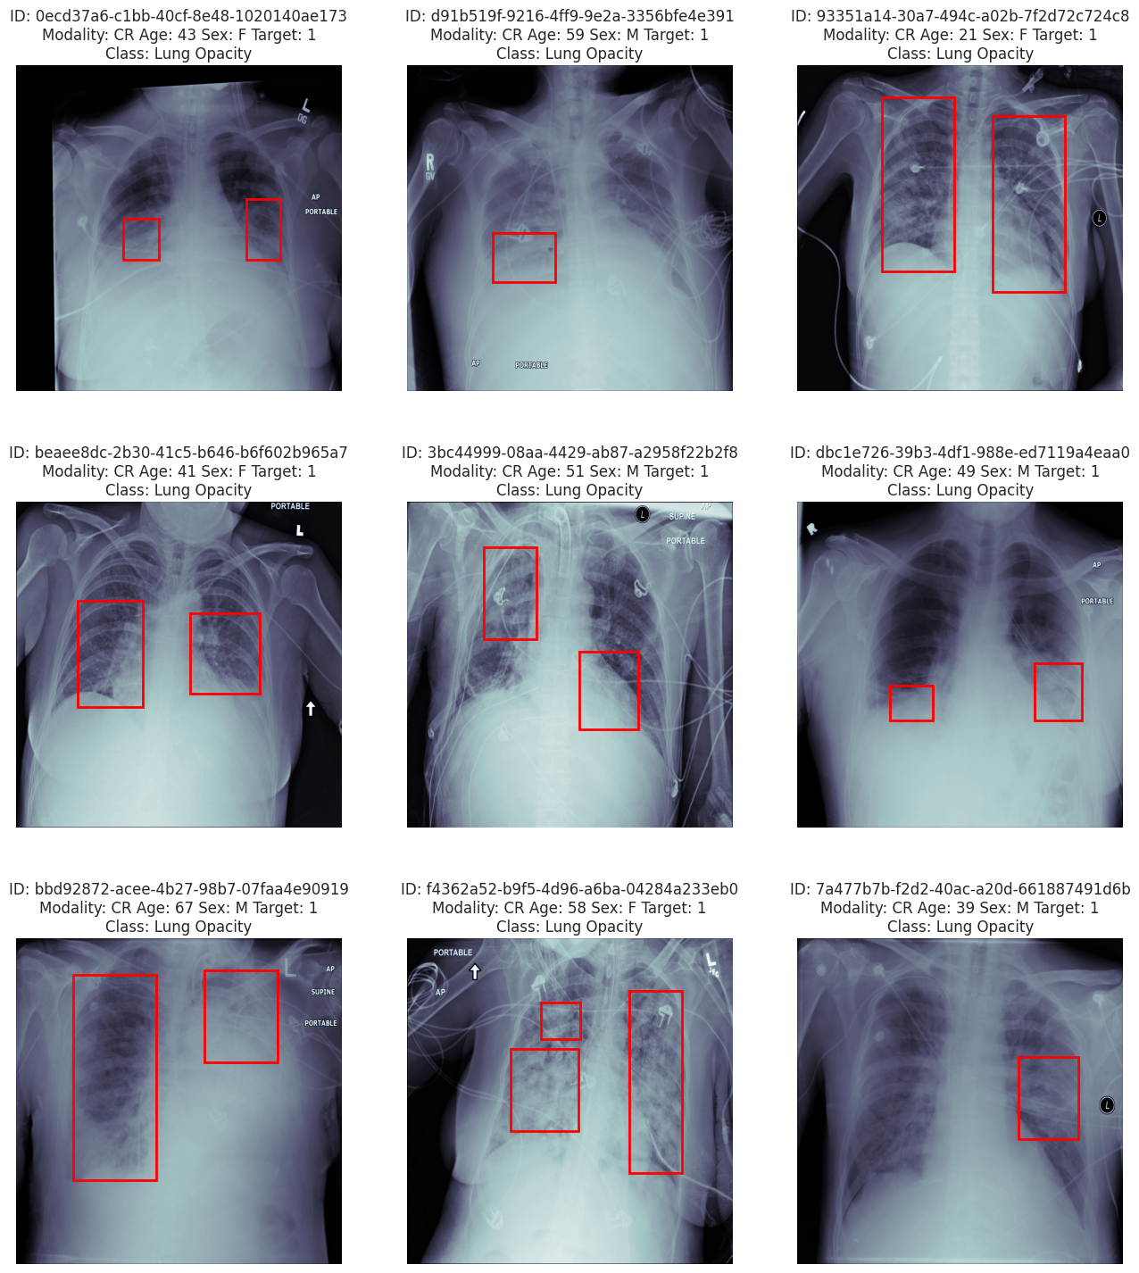



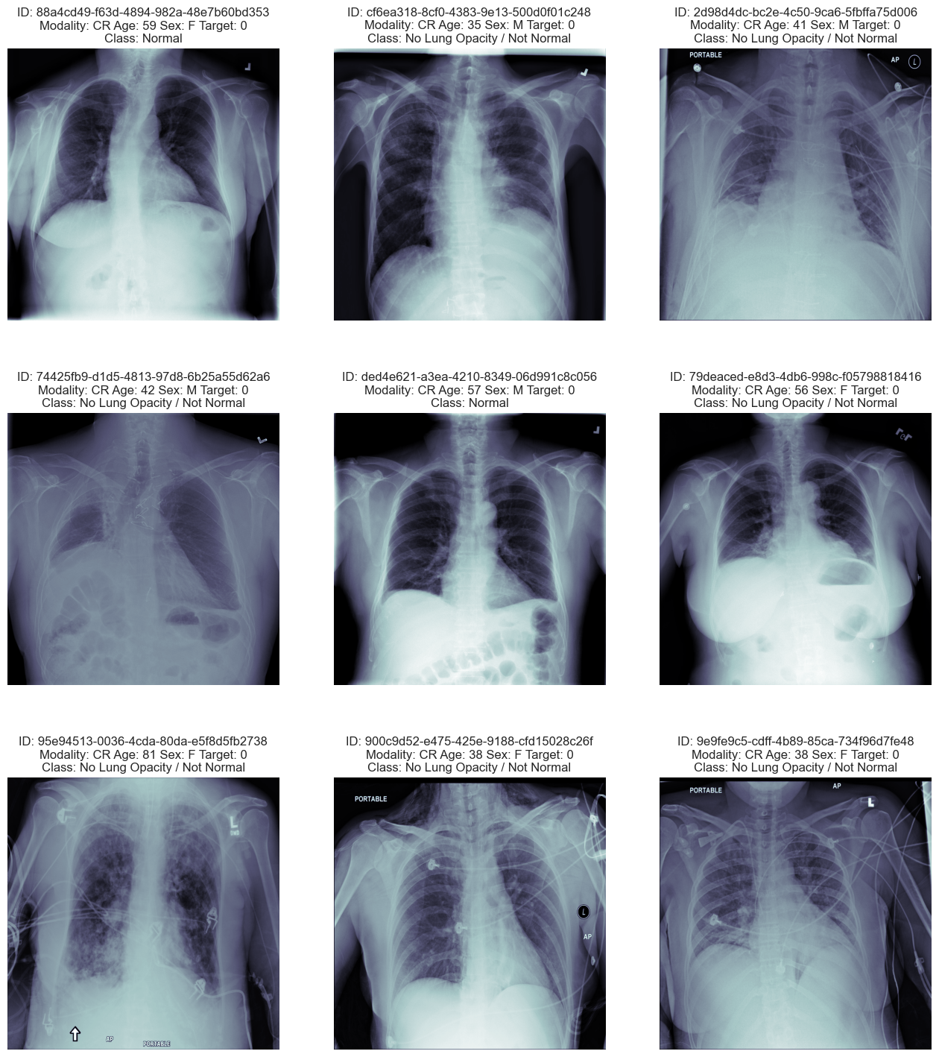

We can see the head of traindf data below.

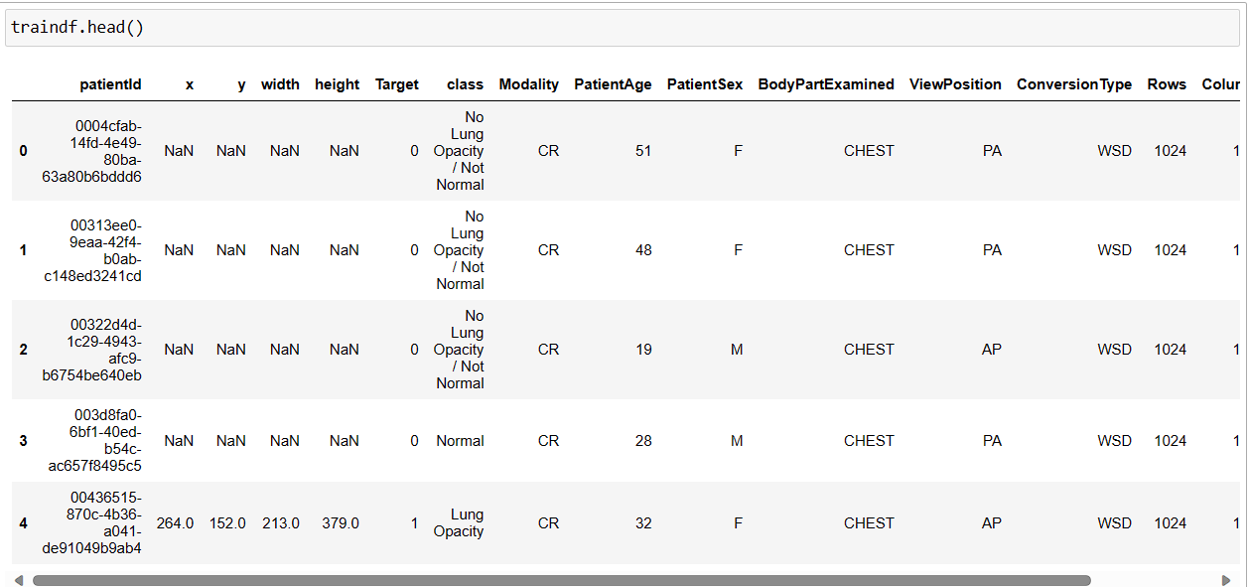

We can see the head of testdf data below.

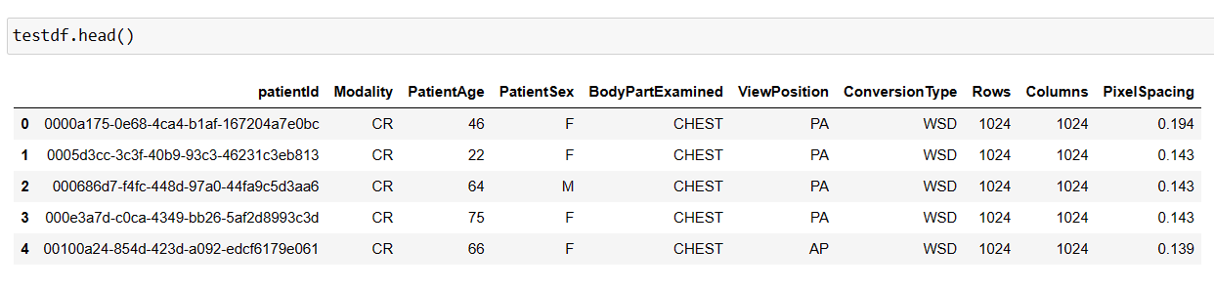

Below is count plot using Seaborn to visualize the distribution of classes ('Normal' and 'Lung Opacity') for different age groups in the training dataset.

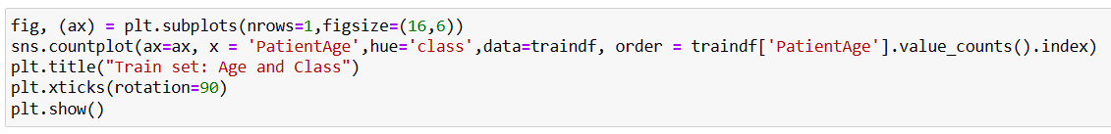

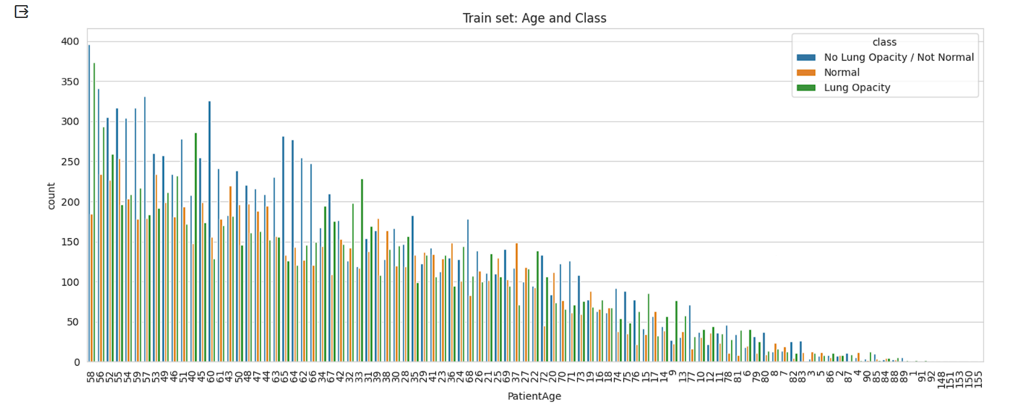

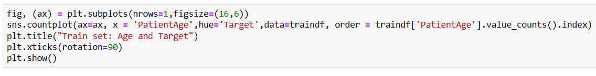

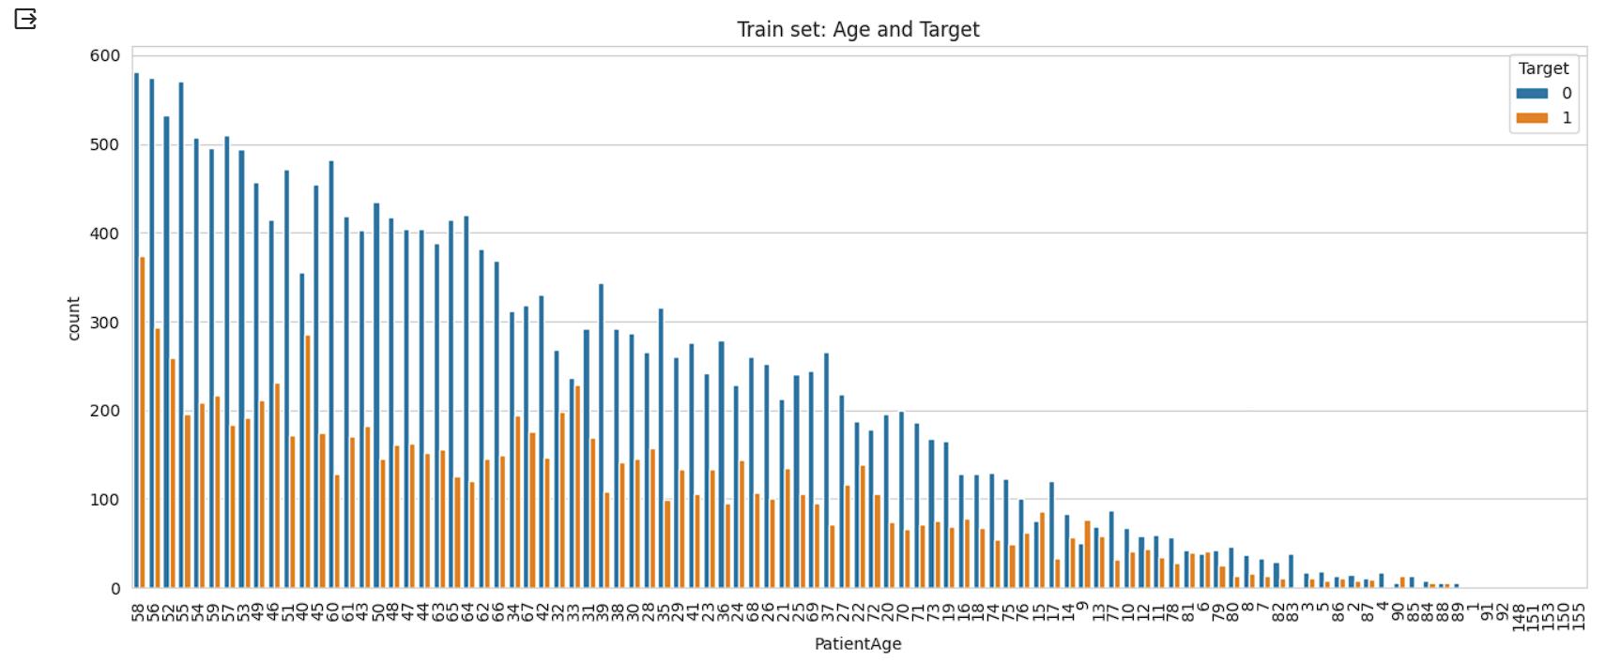

The majority of the data is recorded for individuals aged between 40 to 50. However, an outlier is present with an age of 151. There are limited data points for age groups between 1 to 5 and 80 to 90.

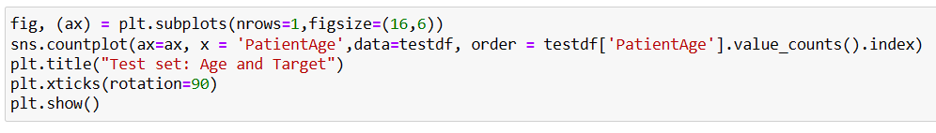

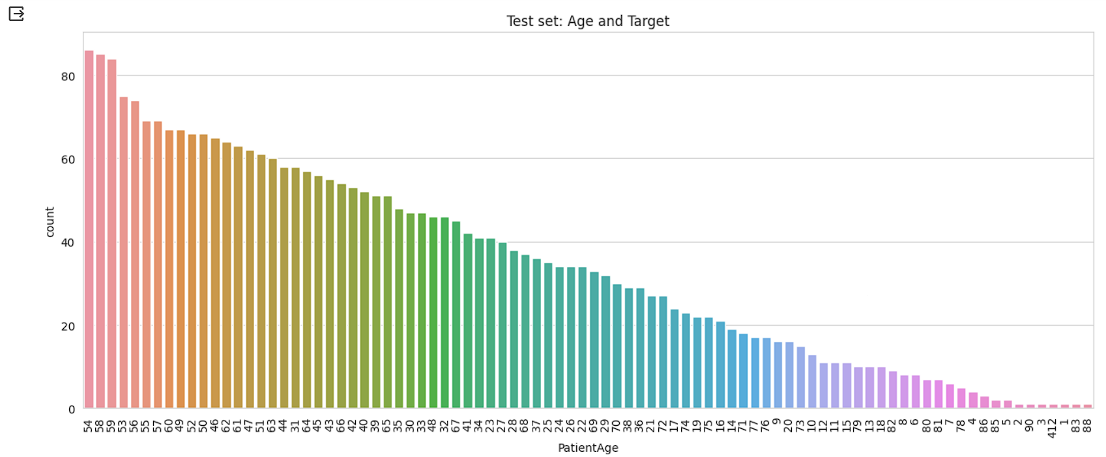

In test set also similar kind of behavior observed in data among different age groups. Outlier with Age 412

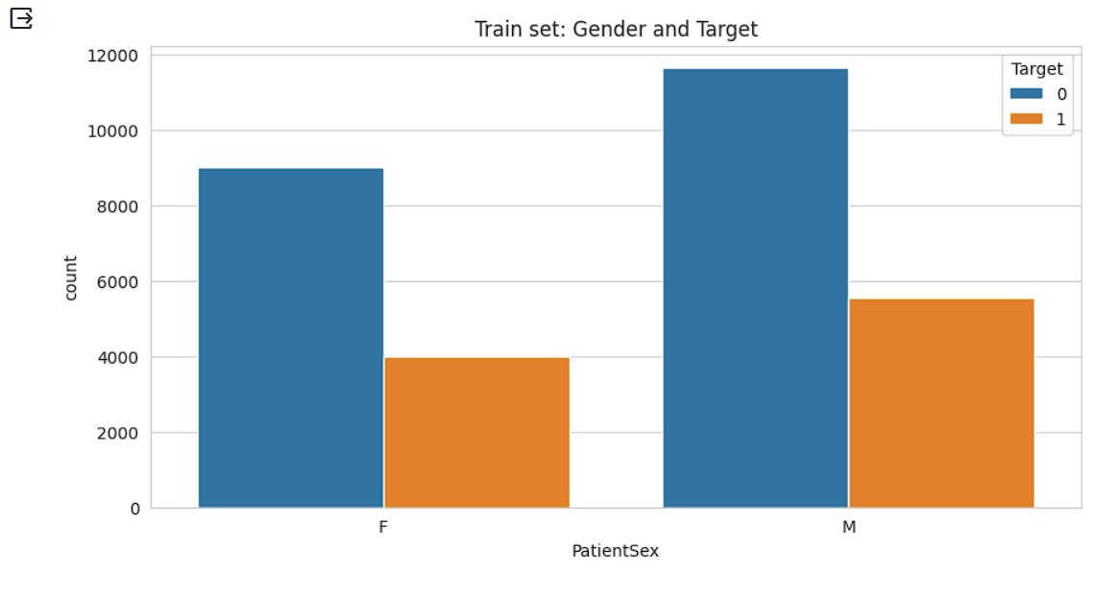

We can see view position below.

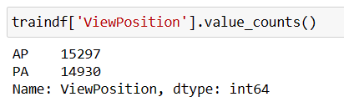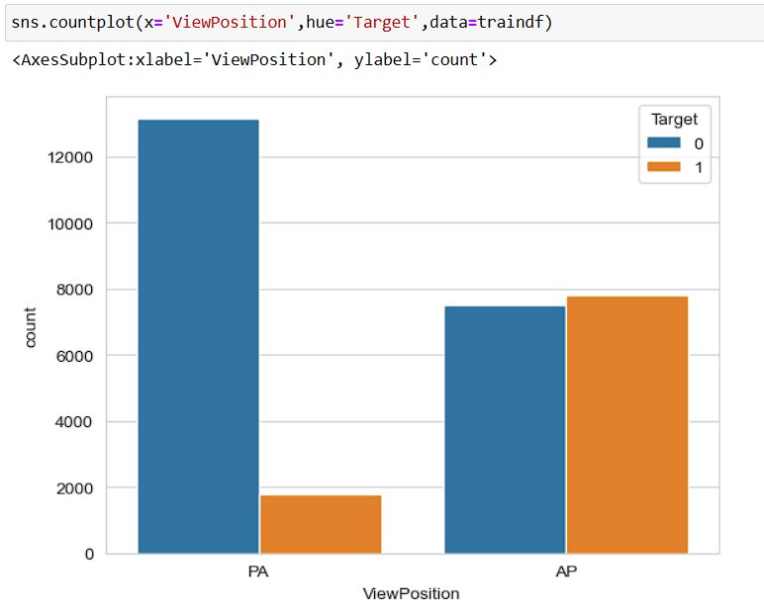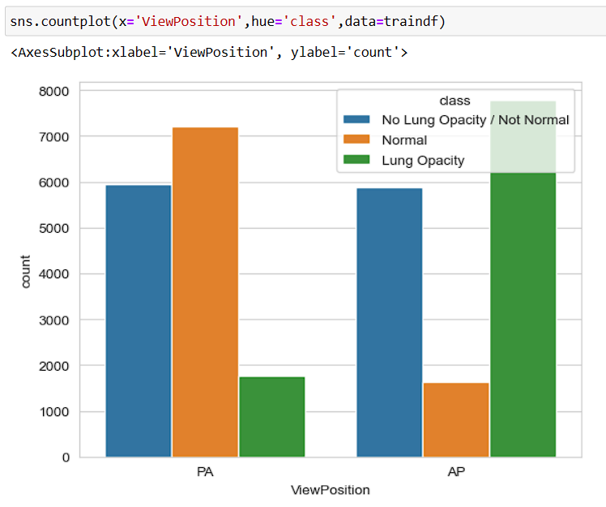

We can see the pre processing of traindf data.

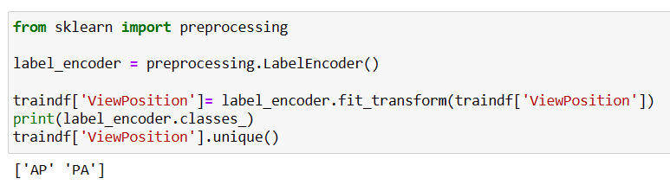

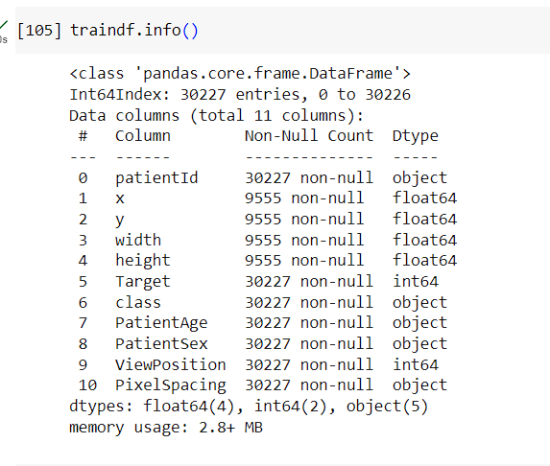

We can see the correlation of traindf.

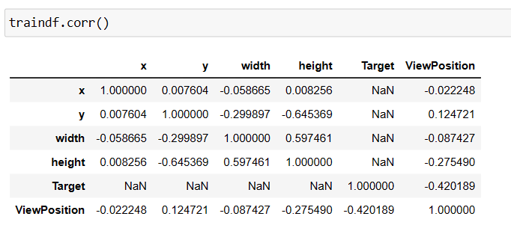

### Step 6: Design, train and test basic CNN models for classification.

We have merged the class info at trainlabels and class info based on patient id.

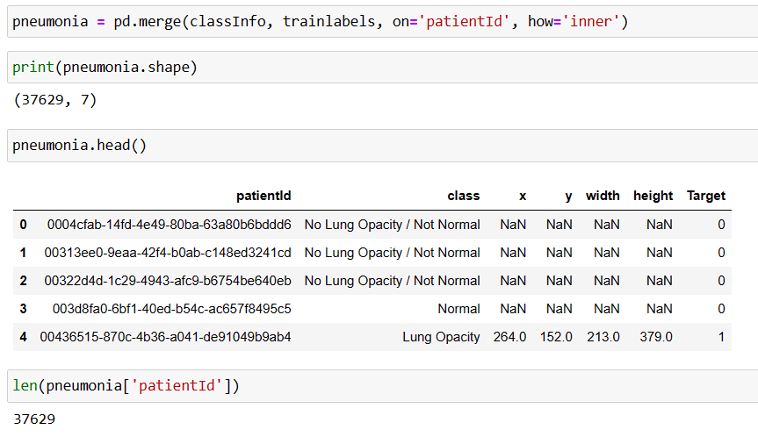

Because the patientId column is duplicated after merging detail_class and bbox_info, we have dropped paitientId from detail_class.

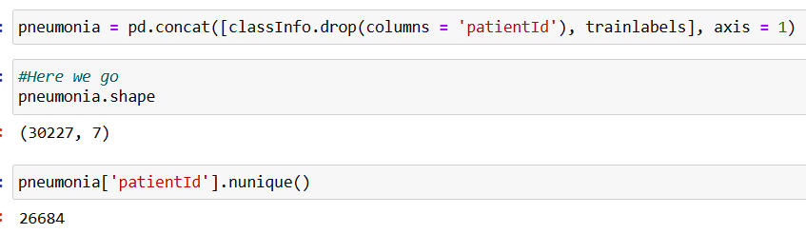

Now we can see the unique records in the above dataset.

We can see the bound inbox parameter in the bbox and dropped x, y, height and width. Below is the final data in the dataset.

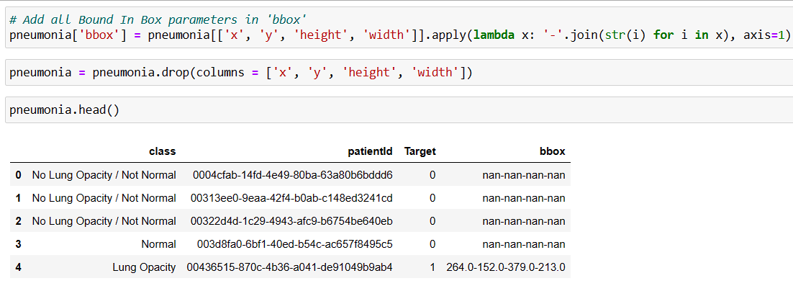

Below is the meta data of random image from train set and find the final dicom_data.

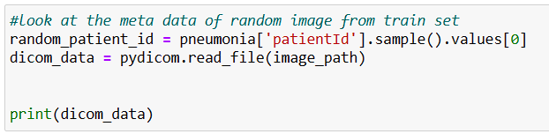

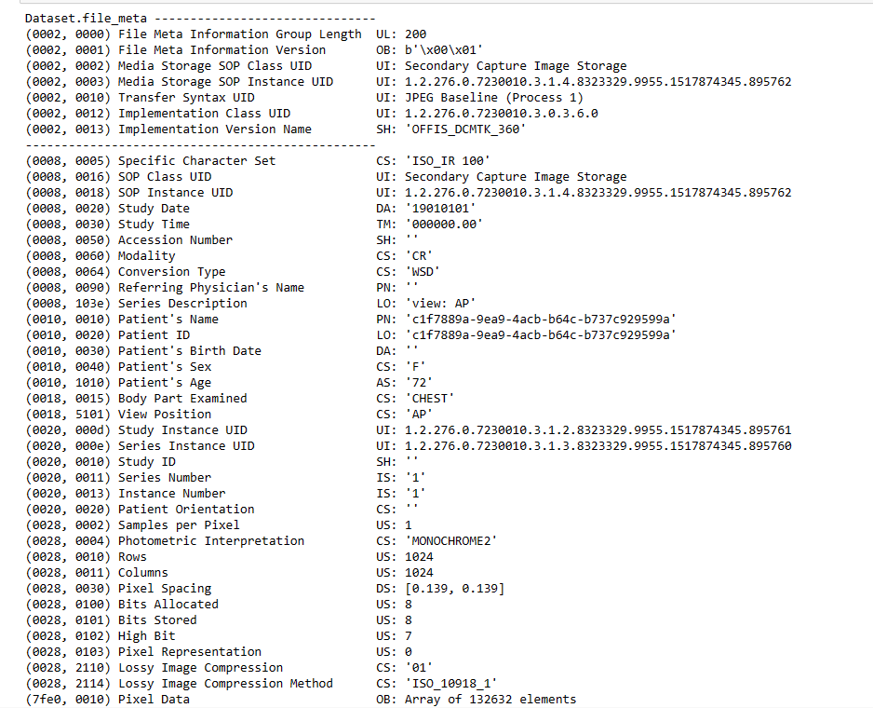

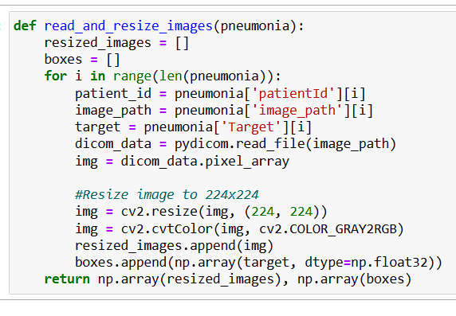

Split the data to Train and Test

We had split the data into train and test as below.

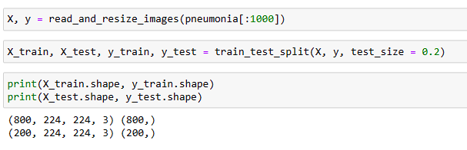

We had used Python function save_img_from_dcm converts the DICOM file to a JPEG image. It uses the pydicom library to read the DICOM file and cv2 (OpenCV) to save the corresponding JPEG image.

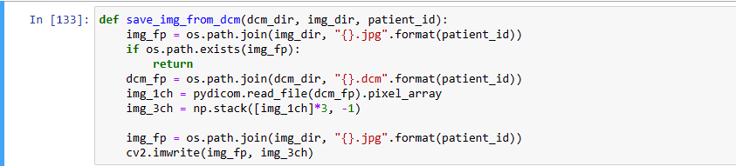

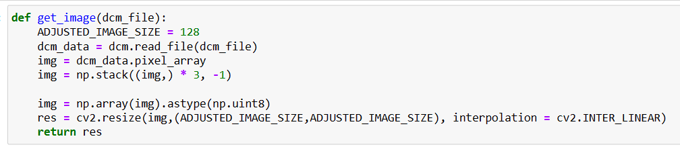

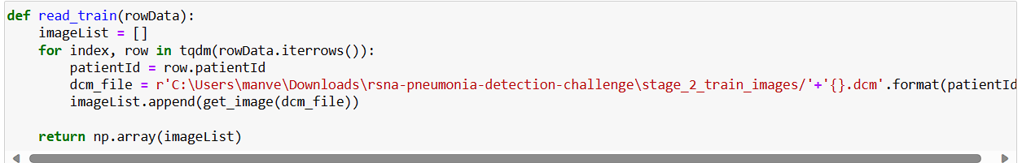

Reading the test data.

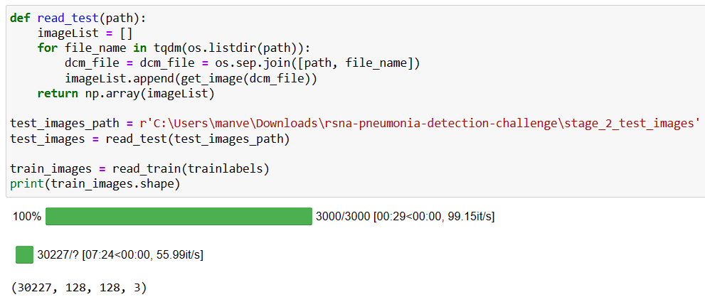

We can see differentiate between the Pneumonia and no Pneumonia in the below images.

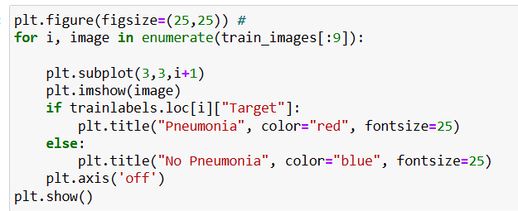

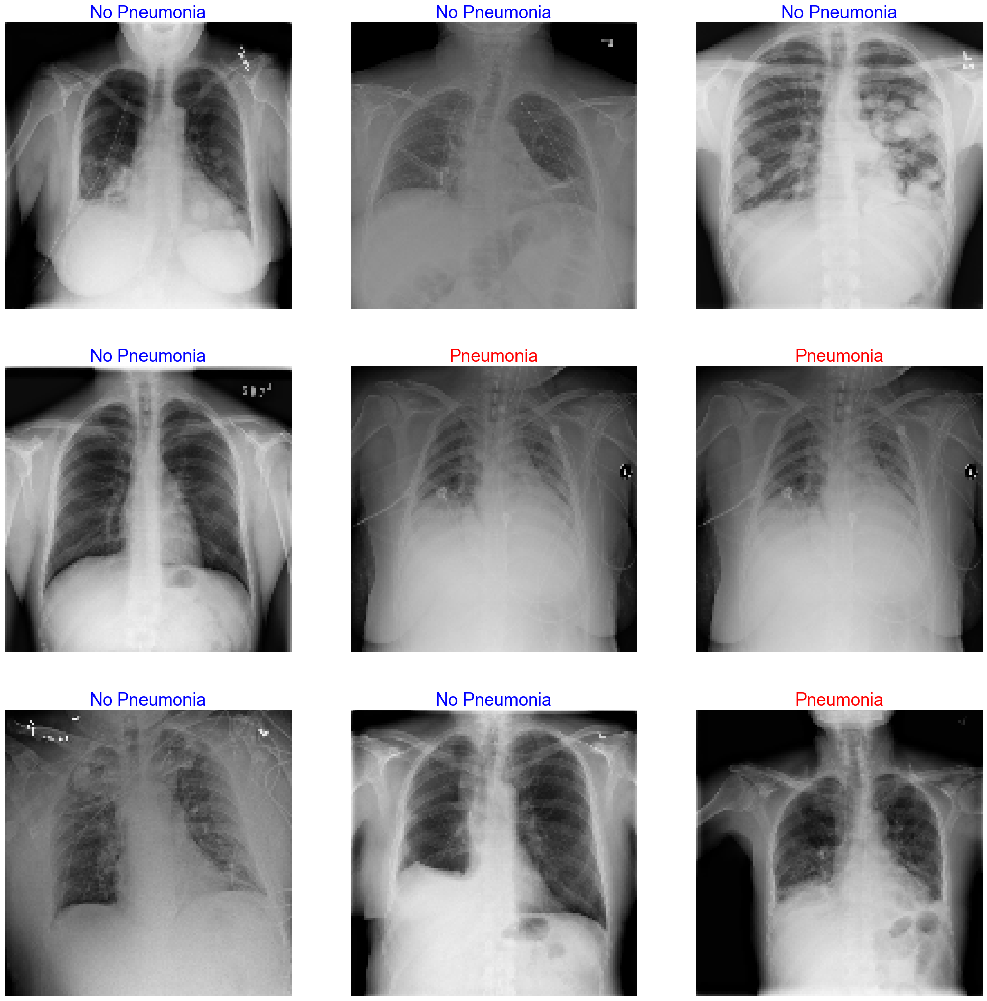

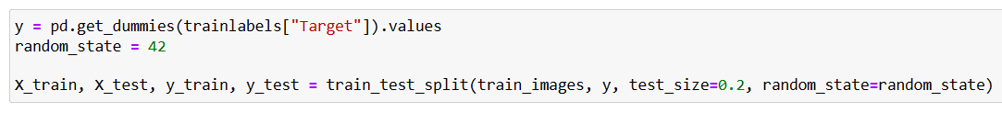

Building CNN Model

Below code defines three custom metrics for evaluating the performance of a classification model: recall, precision, and F1-score.

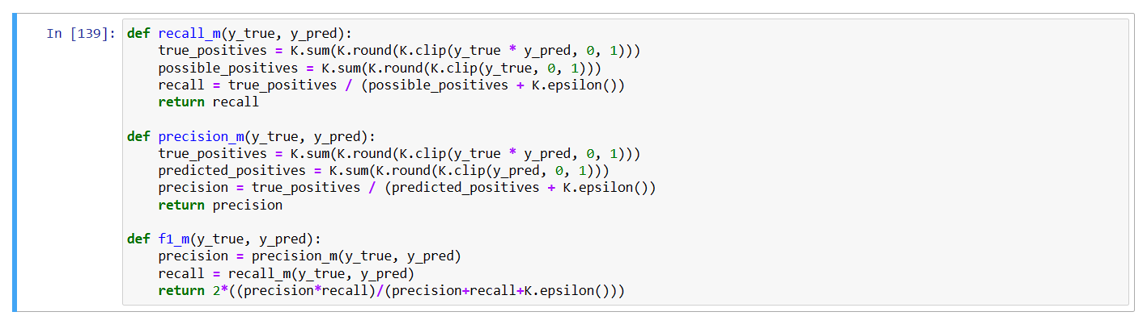

We had used below code to defines and trains a CNN for image classification using TensorFlow and Keras.

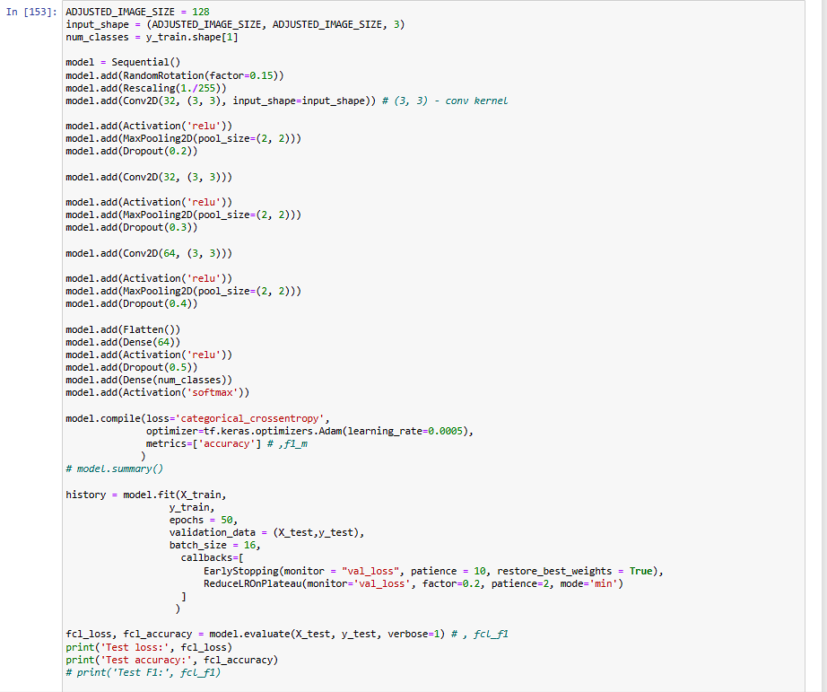

1512/1512 [==============================] - 76s 49ms/step - loss: 0.5525 - accuracy: 0.7063 - val_loss: 0.5068 - val_accuracy: 0.7536 - lr: 5.0000e-04

Epoch 2/10

1512/1512 [==============================] - 74s 49ms/step - loss: 0.5128 - accuracy: 0.7537 - val_loss: 0.5169 - val_accuracy: 0.7545 - lr: 5.0000e-04

Epoch 3/10

1512/1512 [==============================] - 74s 49ms/step - loss: 0.4991 - accuracy: 0.7684 - val_loss: 0.4839 - val_accuracy: 0.7645 - lr: 5.0000e-04

Epoch 4/10

1512/1512 [==============================] - 74s 49ms/step - loss: 0.4903 - accuracy: 0.7733 - val_loss: 0.4840 - val_accuracy: 0.7721 - lr: 5.0000e-04

Epoch 5/10

1512/1512 [==============================] - 74s 49ms/step - loss: 0.4829 - accuracy: 0.7775 - val_loss: 0.4775 - val_accuracy: 0.7713 - lr: 5.0000e-04

Epoch 6/10

1512/1512 [==============================] - 74s 49ms/step - loss: 0.4821 - accuracy: 0.7784 - val_loss: 0.4684 - val_accuracy: 0.7749 - lr: 5.0000e-04

Epoch 7/10

1512/1512 [==============================] - 74s 49ms/step - loss: 0.4754 - accuracy: 0.7790 - val_loss: 0.4724 - val_accuracy: 0.7717 - lr: 5.0000e-04

Epoch 8/10

1512/1512 [==============================] - 74s 49ms/step - loss: 0.4728 - accuracy: 0.7792 - val_loss: 0.4920 - val_accuracy: 0.7653 - lr: 5.0000e-04

Epoch 9/10

1512/1512 [==============================] - 74s 49ms/step - loss: 0.4642 - accuracy: 0.7850 - val_loss: 0.4614 - val_accuracy: 0.7807 - lr: 1.0000e-04

Epoch 10/10

1512/1512 [==============================] - 73s 49ms/step - loss: 0.4647 - accuracy: 0.7857 - val_loss: 0.4574 - val_accuracy: 0.7792 - lr: 1.0000e-04

189/189 [==============================] - 4s 20ms/step - loss: 0.4574 - accuracy: 0.7792

Test loss: 0.4573941230773926

Test accuracy: 0.7791928648948669

189/189 [==============================] - 4s 20ms/step

precision recall f1-score support

0 0.82 0.87 0.84 4135

1 0.67 0.58 0.63 1911

accuracy 0.78 6046

macro avg 0.75 0.73 0.73 6046

weighted avg 0.77 0.78 0.77 6046

**We can see the CNN model Accuracy is 78%.**

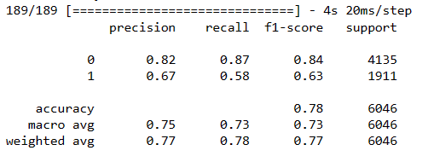

The below graph is a visual representation of how the model's accuracy and loss change during training and validation over different epochs. The training curves depict the model's performance on the training set, while the validation curves show how well the model generalizes to new, unseen data.

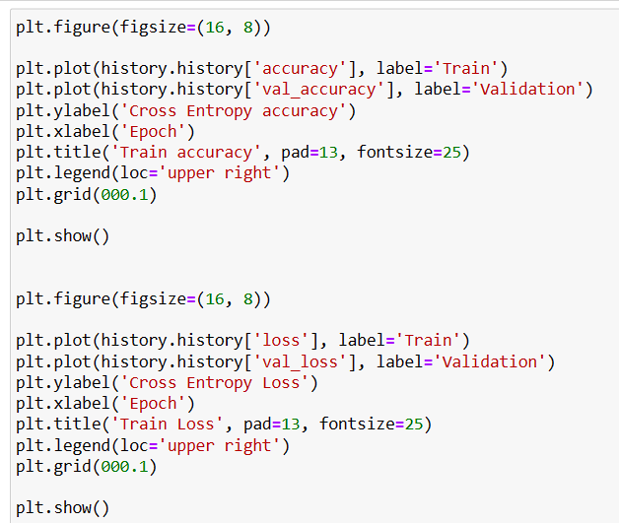

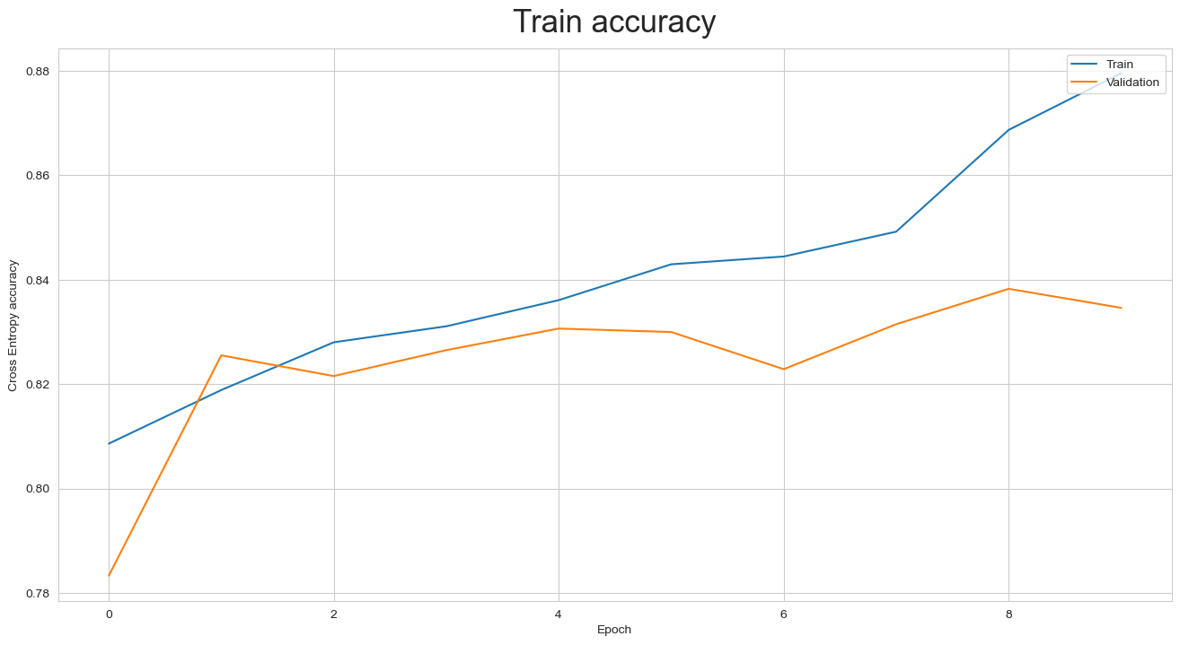

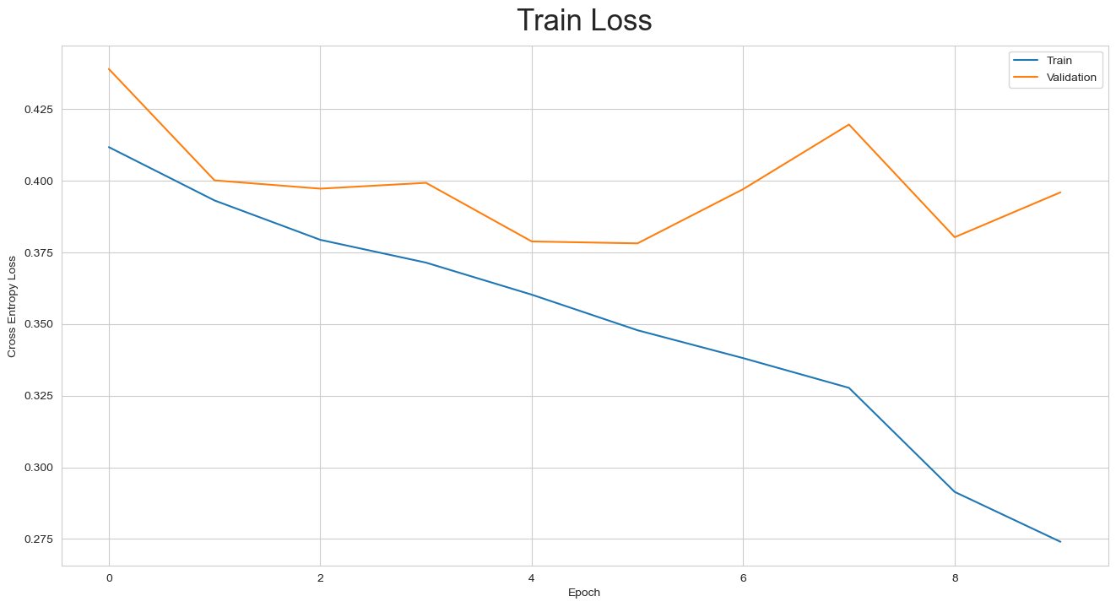

Convolutional Neural Network (CNN)

A Convolutional Neural Network (CNN) is a specialized type of artificial neural network designed for processing and analyzing visual data, such as images.

CNNs have proven to be highly effective in various computer vision tasks, including image classification, object detection, and image segmentation. The key innovation of CNNs lies in their ability to automatically and adaptively learn hierarchical representations directly from pixel values.

This is achieved through the use of convolutional layers, pooling layers, and fully connected layers. Convolutional layers apply filters to small, overlapping regions of the input data, enabling the network to capture local patterns and features.

Pooling layers down sample the spatial dimensions, reducing the computational load and focusing on the most critical information.

These layers are typically followed by one or more fully connected layers that combine high-level features for final decision-making.

CNNs excel in feature extraction and pattern recognition, making them the go-to architecture for image-related tasks in fields like computer vision, medical imaging, and autonomous vehicles.

The ability to automatically learn hierarchical representations, coupled with parameter sharing and translation invariance properties, makes CNNs powerful and efficient for visual information processing.

## Milestone 2

### Step 1: Fine tune the trained basic CNN models for classification.

Precision, recall, F1-score, support, and accuracy are metrics commonly used to evaluate the performance of classification models. These metrics are calculated based on the confusion matrix, which is a table that summarizes the performance of a classification algorithm. Here's a brief description of each:

**Precision:**

* Precision is the ratio of correctly predicted positive observations to the total predicted positives.
* It is a measure of how many of the predicted positive instances are actually positive.
* Precision is calculated as TP/(TP+FP)​, where TP is the number of true positives and FP is the number of false positives.

**Recall (Sensitivity or True Positive Rate):**

* Recall is the ratio of correctly predicted positive observations to the all observations in the actual class.
* It is a measure of how many of the actual positive instances were correctly predicted.
* Recall is calculated as TP/(TP+FN)​, where TP is the number of true positives and FN is the number of false negatives.

**F1-score:**

* The F1-score is the harmonic mean of precision and recall.
* It provides a balance between precision and recall.
* F1-score is calculated as (2×Precision×Recall)/(Precision+Recall)

**Support:**

* Support is the number of actual occurrences of the class in the specified dataset.
* It is the number of true instances in each class.

**Accuracy:**

* Accuracy is the ratio of correctly predicted observations to the total observations.
* It is a general measure of the model's correctness.
* Accuracy is calculated as (TP+TN)/(TP+TN+FP+FN), where TP is the number of true positives, TN is the number of true negatives, FP is the number of false positives, and FN is the number of false negatives.

In summary, precision focuses on the accuracy of positive predictions, recall emphasizes the coverage of actual positive instances, the F1-score balances precision and recall, support indicates the number of instances in each class, and accuracy measures the overall correctness of predictions across all classes. It's important to consider the specific goals and requirements of your application when choosing which metric to prioritize.

​

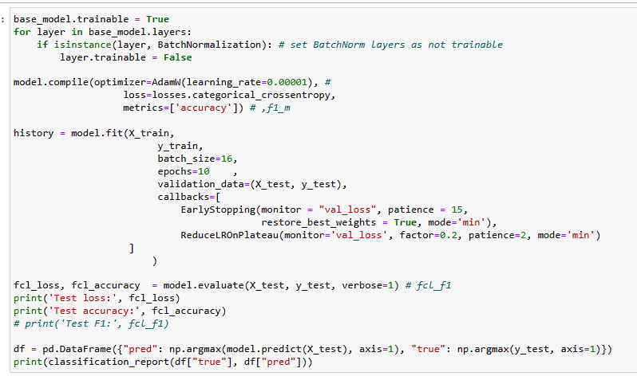

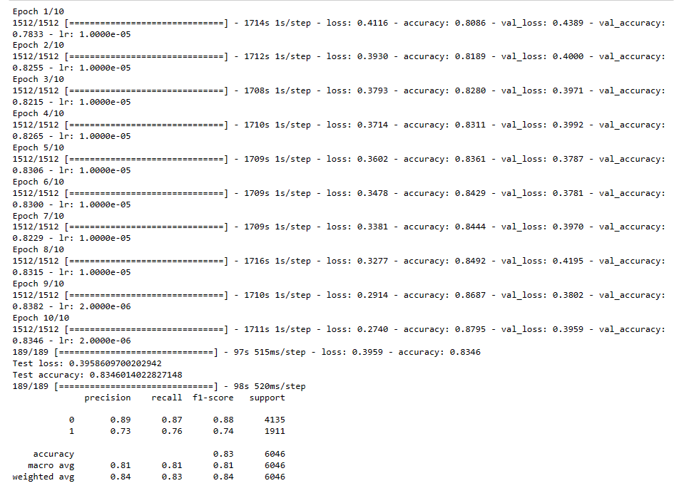

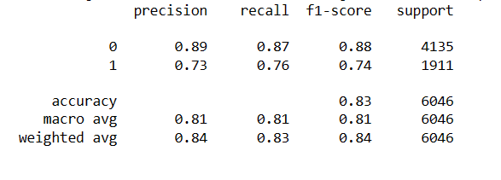

We observed accuracy is improved to 83% after fine tuning the model.

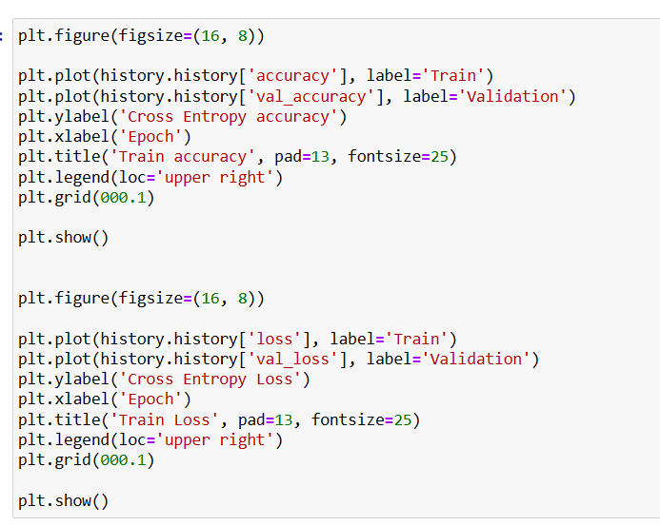





### Step 2: Apply Transfer Learning model for classification

Transfer learning is a machine learning technique that involves taking knowledge learned from one task and applying it to a different but related task. In the context of classification, transfer learning is often used in image, text, or speech recognition tasks. Here's a step-by-step explanation of how transfer learning works for classification:

**Select a Pre-trained Model:**

Choose a pre-trained model that has been trained on a large dataset for a specific task. This model is typically trained on a more general problem, such as image classification, and has learned to extract useful features from the input data. Common pre-trained models include VGG, ResNet, Inception, and BERT for various tasks.

**Remove or Modify Top Layers (Optional):**

Depending on your specific classification task, you may need to modify the architecture of the pre-trained model. If the original model was trained for a different number of classes, you might need to remove or adapt the final classification layers. This step ensures that the model is compatible with your target task.

**Freeze Pre-trained Layers:**

Freeze the weights of the pre-trained layers. This means that during the training of your new classification model, the weights of the pre-trained layers remain fixed and do not get updated. This helps to preserve the knowledge learned by the model on the original task.

**Add New Classification Layers:**

Add new layers to the model that are specific to your classification task. These layers are often referred to as the "head" of the model and are responsible for making predictions on your specific classes. These layers are initialized with random weights and will be trained on your dataset.

**Compile the Model:**

Compile the model with an appropriate optimizer, loss function, and metrics for your classification task. The choice of these components depends on whether you are dealing with binary or multiclass classification and the characteristics of your specific problem.

**Train the Model:**

Train the model on your target dataset using the frozen pre-trained layers and the newly added classification layers. The pre-trained layers help the model quickly adapt to the features present in your dataset, while the new layers learn to make task-specific predictions.

**Fine-tuning (Optional):**

Optionally, you can perform fine-tuning by unfreezing some of the pre-trained layers and allowing them to be updated during training. This is especially useful when you have a larger dataset for your specific task and want to fine-tune the model's learned features.

**Evaluate and Adjust:**

Evaluate the performance of the model on a separate validation or test dataset. Adjust the model architecture, hyperparameters, or perform additional fine-tuning as needed to achieve satisfactory results.

Transfer learning is beneficial when you have limited data for your target task, as it allows you to leverage the knowledge acquired by a model on a more general task. This can lead to improved performance and faster convergence during training.

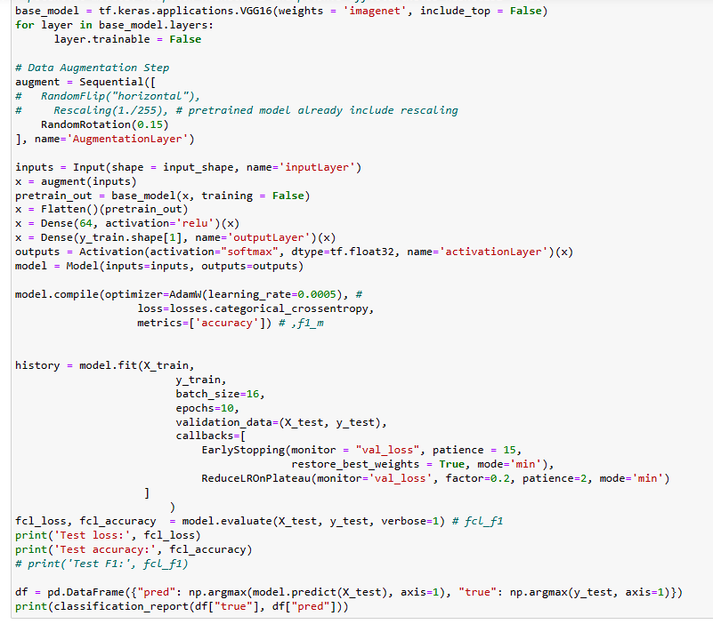

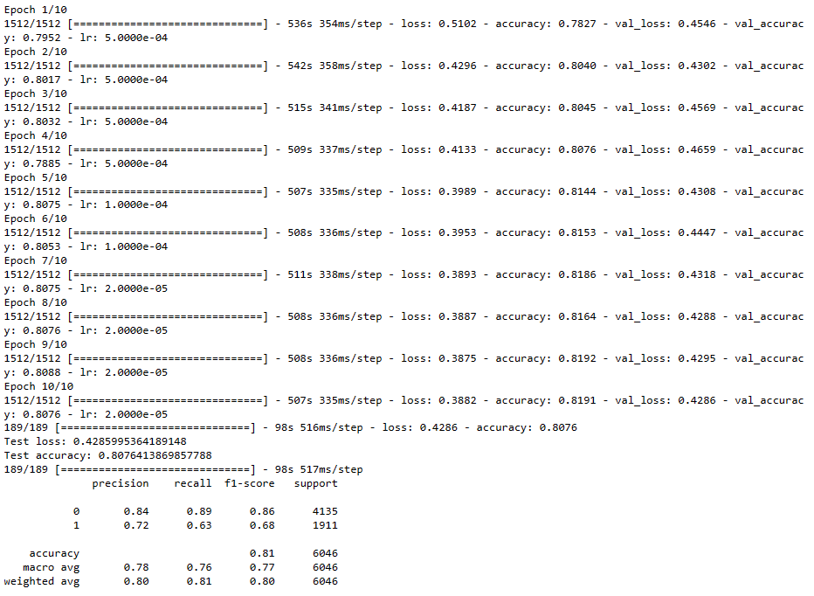

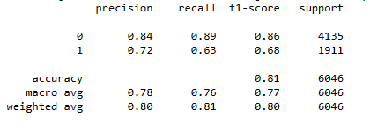

**Applying transfer learning model accuracy improves to 81%.**

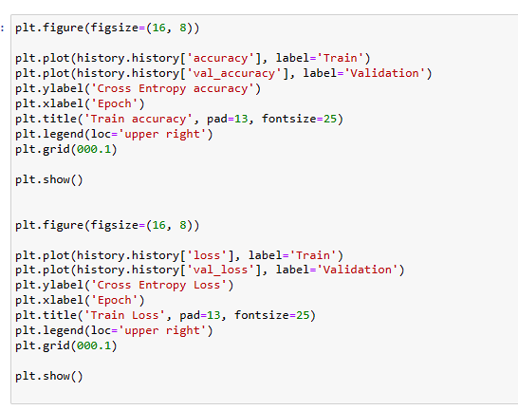

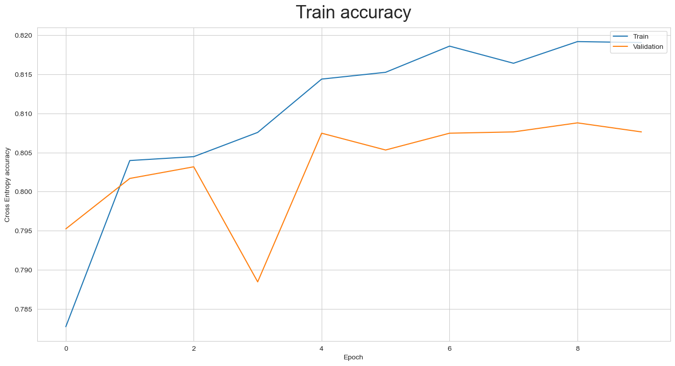

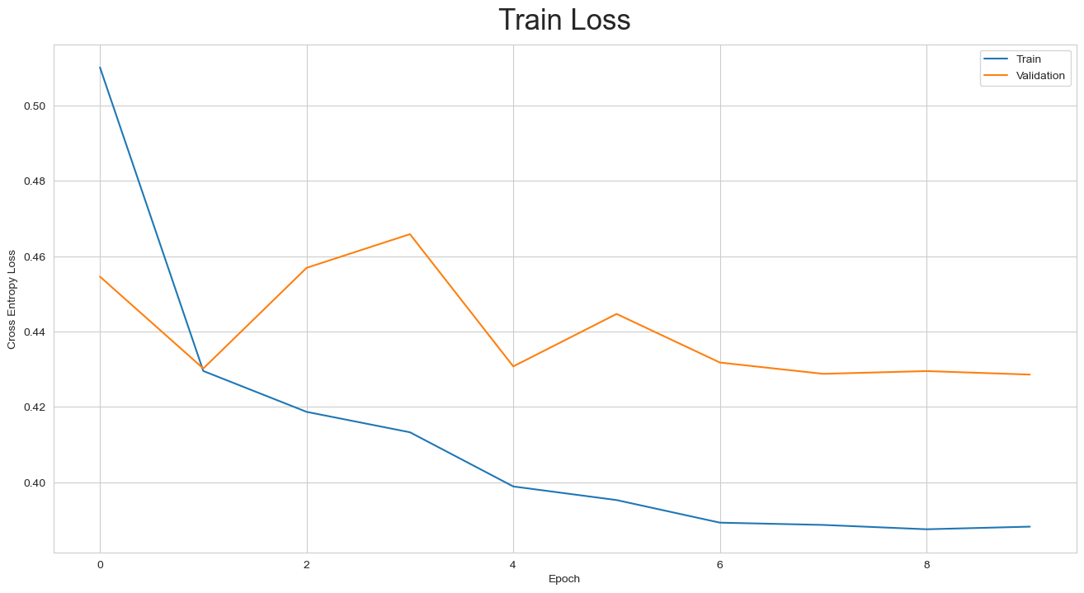

### Step 3: Design, train and test RCNN & its hybrids based object detection models to impose the bounding box or mask over the area of interest.

**RCNN Model:**

The term **"RCNN" (Region-based Convolutional Neural Network)** actually refers to a family of convolutional neural network architectures used primarily for object detection in computer vision. The RCNN models, including their variations like Fast R-CNN, Faster R-CNN, and Mask R-CNN, have significantly improved object detection accuracy in various tasks.

Here's an overview of the general architecture and evolution:

1. **RCNN (Region-based Convolutional Neural Network):**

* Introduced by Ross Girshick, et al. in 2014.
* A two-stage method where regions of interest (RoIs) are proposed using selective search.
* Each region is independently processed through a CNN to extract features, then classified using SVMs.

1. **Fast R-CNN:**

* Proposed as an improvement to RCNN in 2015 by the same authors.
* Introduces a region of interest pooling layer, allowing feature extraction for all regions simultaneously.
* Speeds up the process by sharing convolutional layers for feature extraction.

1. **Faster R-CNN:**

* Proposed by Shaoqing Ren, et al. in 2015.
* Integrates the Region Proposal Network (RPN) into the network architecture.
* The RPN generates region proposals directly from the CNN's feature maps, making the process end-to-end trainable.
* Significantly faster than the previous methods.

1. **Mask R-CNN:**

* Proposed by Kaiming He, et al. in 2017.
* Extends Faster R-CNN by adding a branch for predicting segmentation masks on each RoI.
* Enables instance segmentation, allowing precise pixel-level delineation of objects.

The key features of these RCNN variants include the ability to generate region proposals, extract features, and perform object classification and bounding box regression in a single unified framework. The introduction of RPNs and the integration of these modules into a single network architecture have significantly improved accuracy and efficiency in object detection tasks.

These models have been instrumental in advancing state-of-the-art performance in object detection, instance segmentation, and related computer vision tasks, making them widely used in research and applications across various domains.

The purpose of these variables is to handle the resizing or adjustment of image sizes in a consistent manner, especially when dealing with deep learning models that might have specific input size requirements. The FACTOR is used to scale down the original images to the desired size during preprocessing.

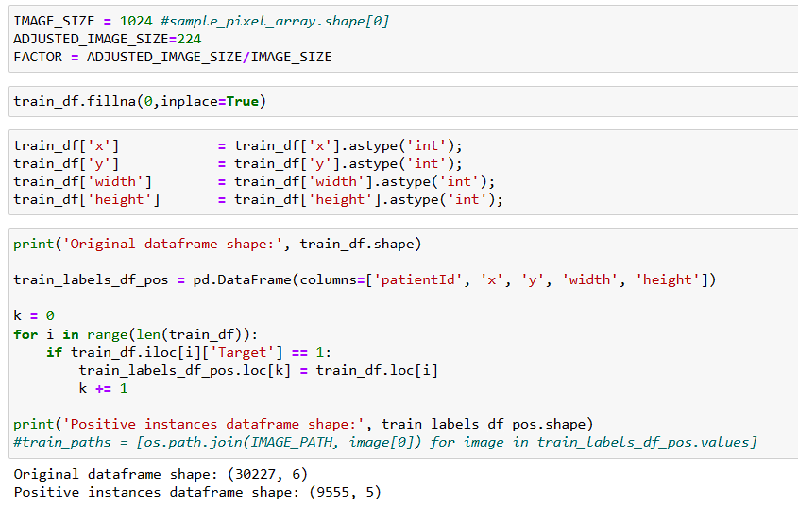

Below code defines a PyTorch dataset class, Pneumonia Dataset, tailored for pneumonia detection tasks. It encapsulates functionalities for loading and preprocessing DICOM images along with associated bounding box information.

The dataset initialization captures unique patient IDs, and the __getitem__ method retrieves preprocessed images and target dictionaries containing bounding boxes, labels, and additional information.

The code also includes functions for data augmentation transformations using the Augmentations library, a collate function for batch processing, and an Averager utility class for computing average values during training.

This dataset class is designed to facilitate the training and validation of a pneumonia detection model in PyTorch.

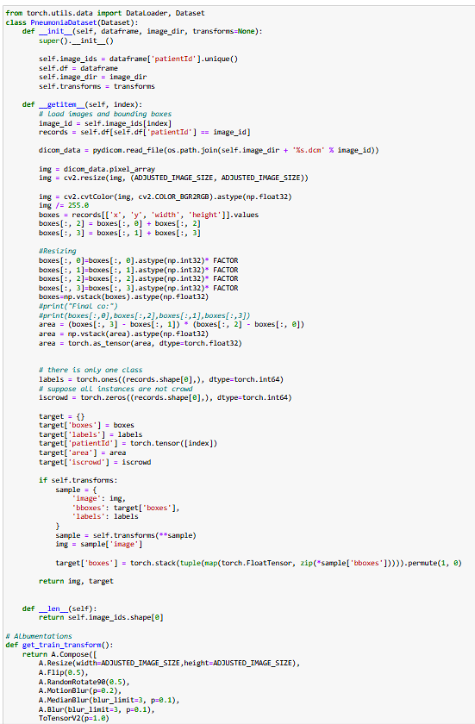

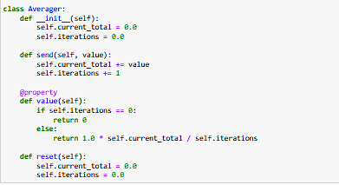

The below code takes a list of patients with pneumonia, splits them into two groups—one for training the model and the other for validating its performance. The sizes of these groups are printed out. Then, it creates datasets for training and validation using these patient groups and applies some image transformations to make the model more robust.

Finally, it sets up data loaders, which help efficiently feed batches of data to the model during training and validation. The printed messages provide information about how many patients are in each group and how many examples are available for the model to learn from.

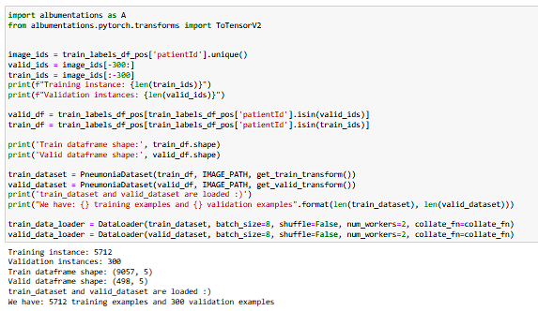

Below code is part of an evaluation process for an object detection model. The primary focus is on measuring the accuracy and precision of the model's predictions.

The Intersection over Union (IoU) is used to assess how well the predicted bounding boxes match the actual objects. The code calculates precision, which quantifies the accuracy of the model by considering true positives (correctly identified objects) and false positives (incorrectly identified objects).

The Image Precision is an average precision score at different IoU thresholds, providing an overall evaluation metric for the entire model's performance in detecting and localizing objects in images. This analysis aids in understanding the effectiveness of the object detection algorithm.

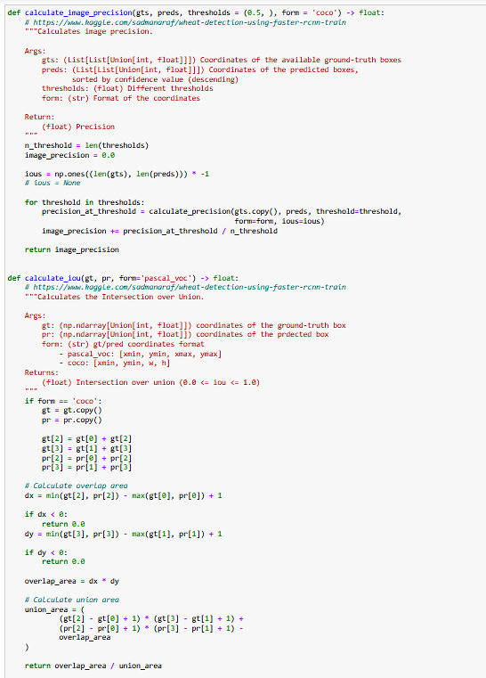

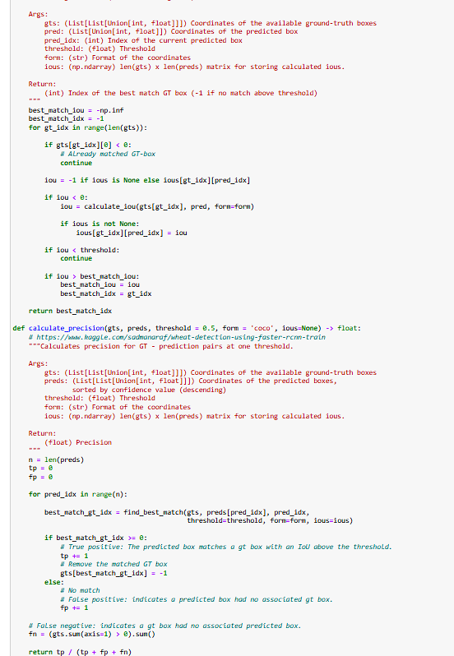

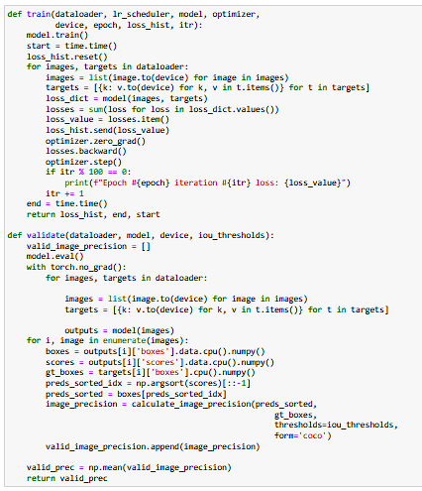

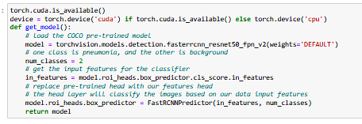

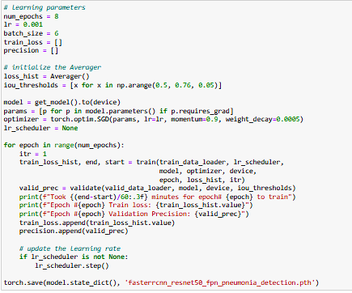

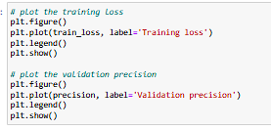

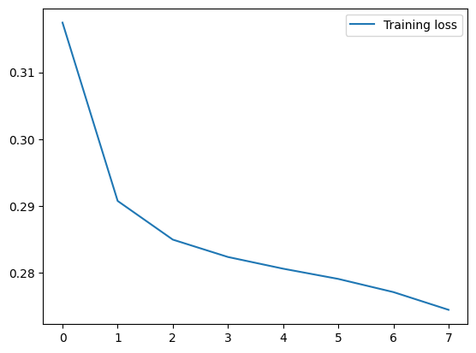

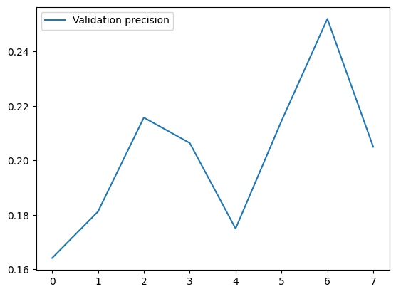

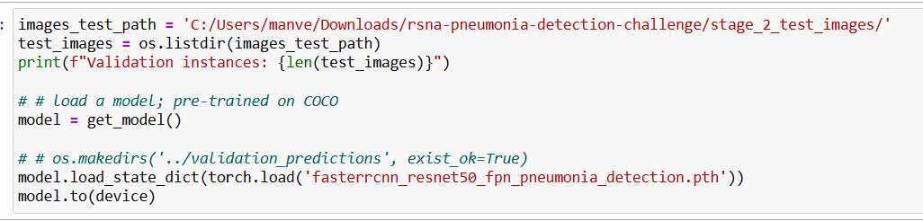

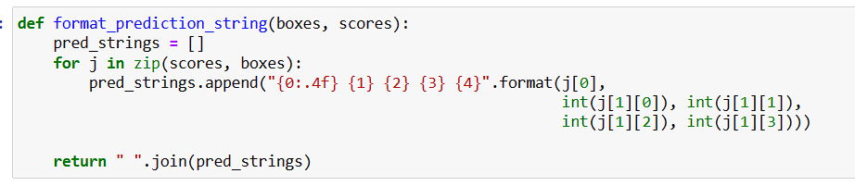

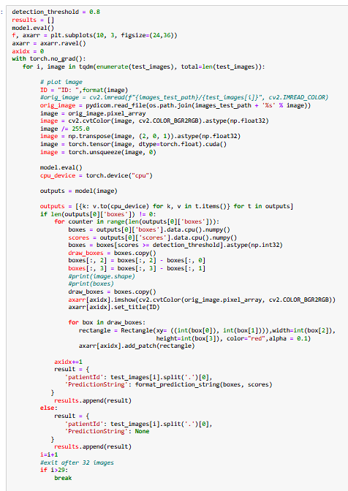

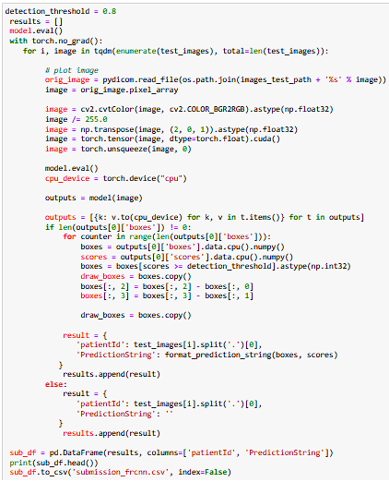

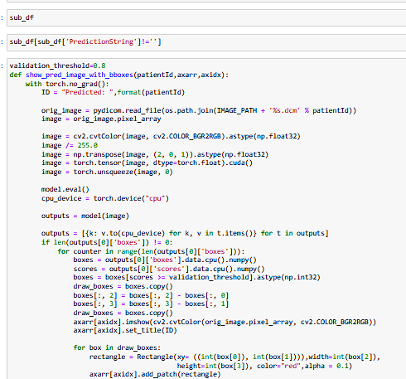

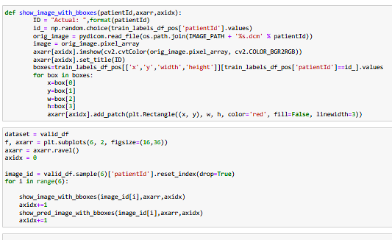

### Step 4: Pickle the model for future prediction

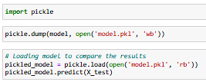

# CONCLUSION

We have used transfer learning model and found the accuracy 81% and have fine tunned the model which results the accuracy to 83%. Then we have used the Faster RCNN model to find the prediction of our Pneumonia detection dataset.

**Project Conclusion and future work**

We tried various models to achieve our goal of building a model with minimal computational resources so that faster and accurate results can be brought out in the healthcare industry, especially the imaging side as it is very computationally heavy. Using the existing data, it was possible to train several models with different configurations and parameters whose accuracies vary between ∼74% and ∼97%; we can conclude that the model's capabilities can be expanded if sufficient training data and advanced computational capability to run further iterations is available as the loss was still decreasing.

In this work, we have presented our approach for identifying pneumonia and understanding how the lung image size plays an important role for the model performance. We found that the distinction is quite subtle for images among presence or absence of pneumonia, large image can be more beneficial for deeper information. However, the computation cost also burden exponentially when dealing with large image.

Our proposed architecture with regional context RCNN with selective search supplied extra context for generating accurate results. Also, using thresholds in background while training tuned our network to perform well in this task. With the usage of image augmentation, dropout and L2 regularization prevented the overfitting, but are obtained something weaker results on the training set with respect to the test. Our model can be improved by adding new layers, but this would introduce even more hyperparameters that should be adjusted. We intend to extend our model architecture in other areas of medical imaging with the usage of deep learning and computer vision techniques.

RCNN with selective search has very limited application for Dicom image analysis due to its architecture. The performance of other models has been better as compared to RCNN. Yolov3 was able to predict the test images with good performance. But Faster-RCNN predicted 1098 test images out of 3000 samples with high confidence score. Hence, both YOLO and Faster RCNN can be taken up for further tuning in next phase of project.

**Improvements Area:**

Due to memory and GPU requirements, not all training data could be loaded. This can be fully used for better model training.

Running the training for more epocs with higher patience levels

Increasing the image dimension being used from 224 to 512px or above.

Stratified sampling of data for training gives the model less opportunity of learning the needed feature in turn leaving the model with fewer accuracies as here only 1/3rd data is of the positive class.

Different variants of image augmentation can be tried.

While the results are promising, there are several avenues for future research:

* + **Clinical Validation:** Our model needs to be tested in a real-world clinical setting to assess its efficacy and reliability further.
  + **Model Explainability:** Future work can also focus on making the model more interpretable for clinicians, possibly through the use of attention mechanisms or other explainability techniques.
  + **Multi-Modal Approaches:** Incorporating additional data types, like patient history or other diagnostic tests, could potentially improve the model's predictive power.
  + **Low-Resource Settings:** Optimizing the model for deployment in low-resource settings could have a significant impact, making high-quality diagnosis accessible to underserved populations.

In future, it would be interesting to see or use medical dataset repository as it would be instrumental in advancing computer vision and deep learning research for medical field. As more and more advanced architectures are emerging, we can look at more accurate classification and localization models to diagnose pneumonia. We could also look at a historical progressive monitoring of the patient and affected region, assisting the pulmonologist in a visual analysis of the patient’s on-going condition.

**Thank You**